May 9th, 2010
Hi
Well, first of all, its ‘Happy Birthday’ to Gavin for Friday. Take your pick of birthday cards! Actually, these are the ones I used last year!

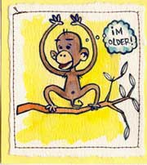
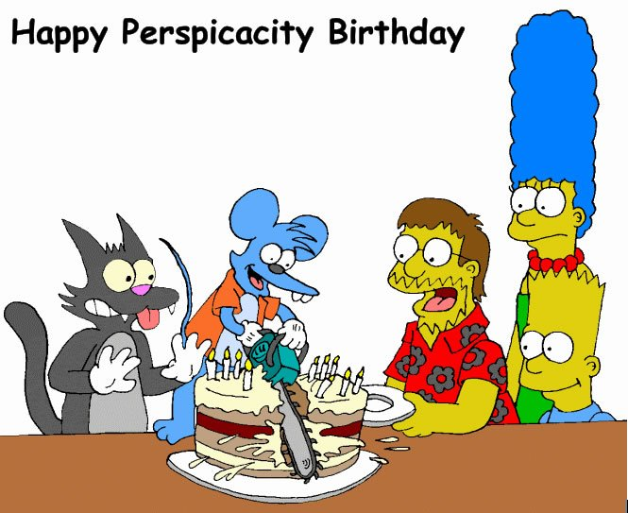

Not much else to write about. In last week’s letter, there are a couple of things I forgot about. First, when going through the stuff in Keith’s attic, I came across small photos of Leonie and Nadine framed by green stones. Were these given to Nana and Granddad? Anyway, I brought them back here. Second, when in Christchurch, I bought six pairs of glasses of various strengths ranging from +1.25D to +2.5D. Most of them were only NZ$2 each! Such glasses are Ok providing both eyes are the same. The glasses I use now, also bought cheaply in NZ some years ago are +1.5D, but were a little more expensive and were only sold at the ‘Warehouse’; now you can but them in many places. I thought I might as well get some in case they are needed.
Not much in HK. We had our first severe thunderstorm of the summer the other night. Had three swims of 1.8 km each. Yesterday, a man with a chopper went on the rampage in a housing estate in Kwai Chung, killing two and seriously injuring several others. Turns out that the man is a mental patient who was released early. A similar thing happened a few months ago with another released mental patient. This kind of knife rampage is happening a lot in China. Several have happened in primary schools. And on the radio news just a few minutes ago, there was a report of another fatal stabbing rampage.
I saw on the BBC news last night that yesterday was VE day (WWII Victory in Europe day). Saw the leaders of the three British political parties (who, following the election still have to sort out who is going to be the next PM) laying wreaths and noticed that they too were wearing red poppies, so maybe the poppy is now a symbol for all war remembrances.

Tomorrow morning I go to the clinic to have two small biopsies, one on a side of the nose (other side tested some time ago and is superficial BCC positive) and the other on a leg. For the leg, asked them to cut out a larger area so that, if it is positive, the whole positive area may be able to be removed as happened during an excision on my back some time ago. As I will not be able to have a swim tomorrow afternoon, I will probably go this afternoon. I have never been on the weekend as the pool is usually more crowded.
Last night I actually watched a movie on TV – or at least, part of one. It was the animated movie ‘Madagascar’. Seen it? I only watched it because, when in Indonesia a few months back, the Maths presenter said that it was a good movie. I wouldn’t rave about it though. Made a recording in case I want to watch the rest of the movie sometime.
That seems to be it for now.
Cheers

